**Quarterly Report 1**

|  |  |  |  |  |  |  |  |  |  |  |  |  |  |  |  |  |  |  |  |  |  |  |  |  |  |  |  |  |
| --- | --- | --- | --- | --- | --- | --- | --- | --- | --- | --- | --- | --- | --- | --- | --- | --- | --- | --- | --- | --- | --- | --- | --- | --- | --- | --- | --- | --- |
| **Enhancing the capacity of local actors in efforts to improve Peace and Stability in North Africa, the Sahel and Great Lakes**  **Award ID: 00080290-CCCPA Phase II**  **March 1 – May 31 2014**  **Introduction**  Since the inception of continental cooperation in Africa, Egypt has been a champion of pan-African causes. It has also been a bastion of efforts to achieve peace and stability in Africa, including by building African capacities. For those purposes, the Egyptian Ministry of Foreign Affairs established the Cairo Center for Conflict Resolution and Peacekeeping in Africa (hereinafter CCCPA) in 1994. Since 2008, CCCPA has been the recipient of continuous support from the Government of Japan through the United Nations Development Programme (UNDP), with the aim of strengthening its institutional capacity and enhancing its ability to provide various partners in the region with trainings to build capacities in peacebuilding and peacekeeping.  Despite the huge efforts of the international community, Africa continues to be a conflict-ridden, with devastating consequences on human security and serious repercussions for global peace and security. Some North African countries continue to struggle as a result of the socioeconomic and political upheavals of the last three years, with protracted transitions and mounting threats to peace and security, including state failure, porous borders and terrorism. The Sahel/Sahara and Great Lakes regions continue to suffer from a plethora of longstanding and complex sources of insecurity and instability. Facing such challenges requires a joint effort among the countries of the region, as well as enhancing the capacity of local actors. This project aims at meeting such needs. Taking into account past achievements and lessons learnt, the proposed project aims to enhance the capacities of national and regional actors in the areas of border management, peacekeeping and peacebuilding, conflict resolution and crisis management, to ensure they have the necessary skills for appropriate and timely responses to incidents that threaten peace and stability.  The expected project’s outputs are:   * Improved knowledge in border management in North Africa and the Sahel * Greater understanding of and improved skills in Peacekeeping and Peacebuilding issues in North Africa, the Sahel and the Great Lakes Region * Improved knowledge and skills in conflict resolution and crisis management in North Africa, the Sahel and the Great Lakes Region * Project Management Unit established and operational.   Having been scheduled to start on March 1st 2014, the project document has not been officially signed except on May 21st 2014 which has caused delays in disbursing project funds through UNDP [[1]](#footnote-1) as CCCPA has not received any transfer of funds for the purpose of implementing this project during the first quarter. Nevertheless, CCCPA utilized the first quarter to set up the team executing the project and initiate contacts with potential partners both inside Egypt and abroad, most notably African peacekeeping and support centers funded by the government of Japan to ensure synergy, establish cooperation and exchange experiences. In addition, the first quarter of the project was also utilized to conduct preliminary needs assessment for the areas covered by the project and to identify research areas and partners. An in-mission training was conducted for the African Union Mission in Somalia (AMISOM). The training’s importance stems from its focus on streamlining gender in ongoing peace missions, following the United Nations Security Council Resolution 1325, and at a time when Egypt’s membership in the African Union was suspended, which is further testimony to the recognition of CCCPA in Africa.  This report presents the main project activities during the period from March 1 to May 31 2014.  **1. Project Issues:** | | | | | | | | | | | | | | | | | | | | | | | | | | | | |
| **Updated Project Risks:**  The project duration is from 1stMarch 2014 to 28th February 2015. However, the signature of the project document took place on 21stMay 2014, thus raising the possibility for the need to extend the project beyond 28th February 2015. | | | | | | | | | | | | | **Updated Project Issues:**  CCCPA is planning to increase its planned activities during the second half of 2014.In addition, the hiring of Research Officers and short-term technical consultants will be finalized to ensure the carrying out of the required activities. | | | | | | | | | | | | | | | |
| **2. Project Performance** | | | | | | | | | | | | | | | | | | | | | | | | | | | | |
| **OUTPUT No. 1**: Improved knowledge in border management in North Africa and the Sahel  **Deliverable Description:**  During this quarter, CCCPA successfully hired new qualified full time staff for border management issues, as well as identifying possible consultants who will assist in the technical training programmes and curriculum development.  **Target** : March 2014 – February 2015  **Achievement of** : March-May 2014 | | | | | | | | | | | | | | | | | | | | | | | | | | | | |
| Activity ID: **Activity Result 1-1: Training methodology, curricula and partnerships are developed**  **Deliverable Description:**  **Indicators:**   * *Number of technical staff recruited*   CCCPA recruited one Programme Associate to carry out the border management activities and published ToR for the Research Officer on the UNDP website.   * *Number of coordination meetings with counterparts conducted*   A preparation of the coordination meeting with counterparts from the Egyptian Ministries of Defense, Interior, and Justice to understand their training needs took place during this quarter. Additionally, a mission has been conducted to Brussels from 17 to 21 March 2014, in which meetings had been held with North Atlantic Treaty Organization *(*NATO), European External Action Service (EEAS), and European Security and Defense College (ESDC) to get information on the curriculums applied in these institutions, and to explore possibilities of cooperation in this regard. A first draft of the Small Arms and Light Weapons (SALW) curriculum had been designed based on a mission CCCPA conducted from 4 to 10 May 2014 on Oberammergau, after attending (SALW) course held at the NATO school.   * *Number of research areas identified*   A meeting was held with the project technical staff to identify research areas related to border management.   * *Number of appropriate implementing partners identified*   Potential implementation partners with technical knowledge in border management were identified to assist CCCPA in courses design and training delivery. Contacts were initiated with the United States Institute of Peace (USIP) for cooperation on developing training materials and curricula. A draft Memorandum of Understanding is being developed between CCCPA and USIP regarding potential cooperation in this regard.   * *Number of consultation workshops with implementing partners conducted*   Due to the delay of the signature of the project, this activity was postponed to the 3rd quarter of 2014 (2nd quarter of the project).   * *Number of briefing papers developed*   Due to the delay of the signature of the project, this activity was postponed to the 3rd quarter of 2014 (2nd quarter of the project).   * *Number of training/workshop programs designed*   A list of topics was identified and ToRs for a technical consultant was drafted.  **Current evaluation:**  Start and End Date: March 2014- February 2015  % Progress to date: 20% | | | | | | | | | | | | | | | | | | | | | | | | | | | | |
| Quality Criteria | | | Date | | | | Results of Activities | | | | | | | | | | | | | | | | | | | | | |
| User Perspective | | | | | | | | | | | | | | | Resource Status | | | | | | Timeliness |
|  | | |  | | | |  | | | | | | | | | | | | | | |  | | | | | |  |
| Financial | | | | | | | | | | | | | | | | | | | | | | | | | | | | |
| Account | | Fund | Donor | | R. Party | | | | | | | Budget | | | | | | | | | | Expenditure | | | | | | Balance |
|  | | GoJ | GoJ | |  | | | | | | | 120,000 USD | | | | | | | | | |  | | | | | | 114,098.68 |
| 71615 | |  |  | |  | | | | | | |  | | | | | | | | | | 795 | | | | | |  |
| 71405 | | 5,106.32 | | | | | |
|  | | | | | | | | | | | | | | | | | | | | | | | | | | | | |
| Activity ID: **Activity Result 1-2: Trainings/workshops in the areas of:**   * **Border management mechanisms** * **Small Arms and Light Weapons** * **Human Trafficking**   **Deliverable Description:**  Implementation is not scheduled during Q1.  **Indicators**   * *Number of participants trained on border management (country and gender disaggregated)* * *Number of Workshops/trainings organized on border management topics*   **Current evaluation:**  Start and End Date: June 2014 -February 2015  % Progress to date: 0% | | | | | | | | | | | | | | | | | | | | | | | | | | | | |
| |  |  |  |  |  |  |  |  |  | | --- | --- | --- | --- | --- | --- | --- | --- | --- | | Quality Criteria | | Date | | Results of Activities | | | | | | User Perspective | | Resource Status | | Timeliness | |  | |  | |  | |  | |  | | Financial | | | | | | | | | | Account | Fund | Donor | R. Party | | Budget | | Expenditure | Balance | |  | GoJ | GoJ |  | | 420,000 | | 0 | 420,000 | |  | | | | | | | | | | | | | | | | | | | | | | | | | | | | | | | | | | | | | |
| Activity ID: **Activity Result 1-3: Platform and mechanism to evaluate, follow up and outreach with alumni of training activities is operational**  **Deliverable Description:**  **Indicators**   * *Database of participants developed*   A database has been developed to track future participants and experts in border management trainings.   * *Monitoring and evaluation mechanisms developed*   CCCPA developed a monitoring and evaluation mechanism to provide guidance to CCCPA and its partners (UNDP/GoJ) - through documentation of programme progress and impact, as well as with information, to improve the programme during the implementation and support more cost-effective and sustainable results.  As such, the M&E system will play various roles during the implementation of the project:   1. A valuable source of information for decision making, 2. A mechanism of inter-institutional coordination of activities and, 3. An effective tool for communication of results.   The project’s primary focus is to enhance the capacity development of national and local actors. Therefore, the evaluation system will focus on measuring four kinds of outcomes that should result from a highly effective training program. Those are:   * Level 1 Evaluation—Reaction * Level 2 Evaluation—Learning * Level 3 Evaluation—Behavior * Level 4 Evaluation—Results   A full report describing the monitoring and evaluation system that is now in place is attached.   * *Knowledge gained by participants as measured (End of course evaluation)*   Implementation is not scheduled during Q1   * *Follow up group with available participants and partners to assess impact conducted*   Implementation is not scheduled during Q1  **Current evaluation:**  Start and End Date: March 2014- February 2015  % Progress to date: 50% | | | | | | | | | | | | | | | | | | | | | | | | | | | | |
| Quality Criteria | | | Date | | | | Results of Activities | | | | | | | | | | | | | | | | | | | | | |
| User Perspective | | | | | | | Resource Status | | | | | | | | | | Timeliness | | | | |
|  | | |  | | | |  | | | | | | |  | | | | | | | | | |  | | | | |
| Financial | | | | | | | | | | | | | | | | | | | | | | | | | | | | |
| Account | | Fund | Donor | | R. Party | | | | | | | Budget | | | | | Expenditure | | | | | | | Balance | | | | |
|  | | GoJ | GoJ | |  | | | | | | | 15,000 | | | | | 0 | | | | | | | 15,000 | | | | |
| **OUTPUT 2:** Greater understanding of and skills in Peacekeeping and Peacebuilding issues in North Africa, the Sahel and Great Lakes Region  **Deliverable Description:**  During this quarter, CCCPA successfully conducted one training workshop to improve skills in peacekeeping and peacebuilding issues in North Africa, the Sahel and Great Lakes region.  **Target** : March-May 2014  **Achievement of**: March-May 2014 | | | | | | | | | | | | | | | | | | | | | | | | | | | | |
| Activity ID: **Activity Result 2-1: Training methodology, curricula and partnerships are developed**  **Deliverable Description:**  **Indicators**   * Number of technical staff recruited   CCCPA recruited one Programme Associate to carry out peacekeeping and peacebuilding activities and submitted ToR for the Research Officer on the UNDP website   * *Number of research/situation analysis developed*   During this quarter, CCCPA identified some research areas in order to provide training on peacekeeping and peacebuilding, as well as transitional issues. CCCPA will initiate the contact with *Al-Azhar* Institution to explore the area of the rules of war and peace in Islamic law. Additionally, contact with the Department of Peacekeeping Operations (DPKO) and United Nations Peacebuilding Support Office (PBSO) were conducted and they welcomed  Cooperation with CCCPA. In addition, CCCPA held a meeting with the International Peace Support Training Centre in Nairobi (IPSTC- also funded by the government of Japan) in Cairo to discuss the possibility of partnering in implementing the project, either through using IPSTC’s Mobile Training Unit expertise and/or training materials. In addition, CCCPA and IPSTC agreed to cooperate together in future research papers related to peacekeeping and peacebuilding in Africa.  In addition, CCCPA conducted a mission to Bamako in from 12 to 15 May 2014, in which discussions had been made with Ecole de Maintien de la Paix of Bamako (EMP), and the European New Training Initiative for Civilian Crisis Management ENTRi. During these consultations, a first draft course curriculum had been developed on democratization and rule of law, targeting civilian component of peacekeeping operations. Furthermore, during the mission in Brussels of March 2014, CCCPA collaborated with European Defense and Security College (ESDC) in the design of a peacebuilding training course concept note, which is scheduled to be conducted as a training activity in the upcoming quarters.   * *Number of training/workshop programs designed*   One training program for AMISOM conducted on 4-8 May 2014.   * *Number of research materials published*   Following the identification of the research areas of peacekeeping and peacebuilding, a technical meeting was held in order to outline the research materials. Furthermore, CCCPA discussed with USIP possible cooperation on research and publications.  **Current evaluation:**  Start and End Date:  % Progress to date: | | | | | | | | | | | | | | | | | | | | | | | | | | | | |
| Quality Criteria | | | | | Date | | | | | | Results of Activities | | | | | | | | | | | | | | | | | |
| User Perspective | | | | | | | | | Resource Status | | | | | | Timeliness | | |
|  | | | | |  | | | | | |  | | | | | | | | |  | | | | | |  | | |
| Financial Summary | | | | | | | | | | | | | | | | | | | | | | | | | | | | |
| Account | | Fund | Donor | | R. Party | | | | | | | Budget | | | | | | | | Expenditure | | | | | | Balance | | |
|  | | GoJ | GoJ | |  | | | | | | | 100,000 | | | | | | | |  | | | | | | 87,429.36 | | |
| 71615 | |  |  | |  | | | | | | |  | | | | | | | | 223.00 | | | | | |  | | |
| 71405 | | 12,347.64 | | | | | |
|  | | | | | | | | | | | | | | | | | | | | | | | | | | | | |
| Activity ID: **Activity Result 2-2: Training programs &workshops in the areas of:**   * **Human Rights** * **Rule of Law** * **Transitional Justice** * **Transitional Issues**   **Deliverable Description:**  One training course has been conducted in the first quarter on gender, international humanitarian law (IHL) and human rights in peacekeeping and peacebuilding. The training was held in Cairo from May 4th to 8th, 2014 at the Fairmont Nile City Hotel.  1201   |  |  | | --- | --- | | DSC_0155 | DSC_0045 |   **Indicators**   * *Number of participants trained in peacekeeping and peacebuilding (disaggregated by gender and country)*  |  |  |  | | --- | --- | --- | | ***Total Participants*** | ***Men*** | ***Women*** | | 19 | 12 | 7 |  |  |  |  |  |  |  |  |  |  | | --- | --- | --- | --- | --- | --- | --- | --- | --- | |  |  |  |  | ***Countries*** | |  |  |  | | Kenya | Burundi | Nigeria | Uganda | Burkina Faso | Zambia | Ghana | Sierra Leone | Egypt | | 4 | 1 | 2 | 7 | 1 | 1 | 1 | 1 | 1 |  * *Number of Workshops/trainings conducted on peacekeeping and peacebuilding topics*   One training workshop conducted on gender, international humanitarian law (IHL) and human rights in peacekeeping and peacebuilding.  **Current evaluation:**  Start and End Date: May 2014 – February 2015  % Progress to date: Approximately 15% (one out of 12 training / workshops) | | | | | | | | | | | | | | | | | | | | | | | | | | | | |
| Quality Criteria | | | | | Date | | | | | Results of Activities | | | | | | | | | | | | | | | | | | |
| User Perspective | | | | | | | Resource Status | | | | | | | | | Timeliness | | |
|  | | | | |  | | | | |  | | | | | | |  | | | | | | | | |  | | |
| Financial Summary | | | | | | | | | | | | | | | | | | | | | | | | | | | | |
| Account | | Fund | Donor | | R. Party | | | | | | | Budget | | | | | | | Expenditure | | | | | | | Balance | | |
|  | | GoJ | GoJ | |  | | | | | | | 374,000 | | | | | | |  | | | | | | | 322,588.31 | | |
| 71305 | |  |  | |  | | | | | | |  | | | | | | | 4,214.29 | | | | | | |  | | |
| 71605 | | 17,925.71 | | | | | | |
| 71615 | | 4,967.86 | | | | | | |
| 72120 | | 18,268.14 | | | | | | |
| 72130 | | 485.36 | | | | | | |
| 72145 | | 137.00 | | | | | | |
| 72150 | | 1,767.86 | | | | | | |
| 72505 | | 548.00 | | | | | | |
| 72510 | | 157.14 | | | | | | |
| 72705 | | 310.71 | | | | | | |
| 73105 | | 2,392.86 | | | | | | |
| 74525 | | 236.76 | | | | | | |
|  | | | | | | | | | | | | | | | | | | | | | | | | | | | | |
| Activity ID: **Activity Result 2-3: Platform and mechanism to evaluate, follow up and outreach with alumni of training activities is operational**  **Deliverable Description:**  **Indicators**   * *Database of participants developed*   A database has been developed to track future participants and experts in peacekeeping and peacebuilding issues.   * *Monitoring and evaluation mechanisms developed*   Reported in the previous section ( Activity 1-3)   * *Knowledge gained by participants as measured (End of course evaluation)*   The Monitoring and Evaluation Officer was hired after the training was conducted, thus being unable to carry out a thorough evaluation. CCCPA will seek to compensate for this during the mid-year evaluation of the programme. However, a reaction evaluation of how the delegates felt about the training experience was conducted. Trainees expressed satisfaction with the material presented and the skills acquired through the training. Suggestions for further improvements included increased reliance on interactive sessions.   * *Follow up group with available participants and partners to assess impact conducted*   Implementation is not scheduled during Q1  **Current evaluation:**  Start and End Date: May 2014 – February 2015  % Progress to date: 50% | | | | | | | | | | | | | | | | | | | | | | | | | | | | |
| Quality Criteria | | | | | Date | | | | | | Results of Activities | | | | | | | | | | | | | | | | | |
| User Perspective | | | | | | Resource Status | | | | | | | | Timeliness | | | |
|  | | | | |  | | | | | |  | | | | | |  | | | | | | | |  | | | |
| Financial Summary | | | | | | | | | | | | | | | | | | | | | | | | | | | | |
| Account | | Fund | Donor | | R. Party | | | | | | | Budget | | | | | Expenditure | | | | | | | | Balance | | | |
|  | | GoJ | GoJ | |  | | | | | | | 20,000 | | | | | 0 | | | | | | | | 20,000 | | | |
|  | | | | | | | | | | | | | | | | | | | | | | | | | | | | |
| **OUTPUT 3:**Improved knowledge and skills in conflict resolution and crisis management in North Africa, the Sahel and the Great Lakes Region  **Deliverable Description:**  During this quarter, CCCPA hired new qualified full time staff for the crisis management issues, as well as identifying possible consultants who will assist in the technical training programmes and curriculum development.  **Target** : March 2014- February 2015  **Achievement of**: March-May 2014 | | | | | | | | | | | | | | | | | | | | | | | | | | | | |
| Activity ID: **Activity Result 3-1: Training methodology, curricula and partnerships are developed**  **Deliverable Description:**  **Indicators**   * *Number of technical staff recruited*   CCCPA recruited one Programme Associate to carry out conflict resolution and crisis management activities and submitted ToR for the Research Officer on the UNDP website   * *Number of research/situation analysis developed*   Meetings had been held with Egyptian Ministry of Foreign Affairs, and the League of Arab States (to get acquainted with their cooperation experience in crisis management). In addition, consultations had been held with United Nations Educational, Scientific and Cultural Organization (UNESCO) for the media and conflict trainings, as well as with international alert for the conflict sensitivity training course. Research areas were identified during this quarter in the areas of conflict resolution and crisis management issues.   * *Number of training/workshop programs designed*   Implementation is not scheduled during Q1   * *Number of research materials published*   Following the identification of the research areas of conflict resolution and crisis management, a technical meeting was held in order to outline the research materials.  **Current evaluation:**  Start and End Date:  % Progress to date: Approximately | | | | | | | | | | | | | | | | | | | | | | | | | | | | |
| Quality Criteria | | | Date | | | | | Results of Activities | | | | | | | | | | | | | | | | | | | | |
| User Perspective | | | | | | | Resource Status | | | | | | | | Timeliness | | | | | |
|  | | |  | | | | |  | | | | | | |  | | | | | | | |  | | | | | |
| Financial Summary | | | | | | | | | | | | | | | | | | | | | | | | | | | | |
| Account | Fund | | Donor | | | R. Party | | | | | | Budget | | | Expenditure | | | | | | | | Balance | | | | | |
| 71405 | GoJ | | Goj | | |  | | | | | | 100,000 | | | 12,750.78 | | | | | | | | 87,249.22 | | | | | |
| Activity ID: **Activity Result 3-2: Training programs & workshops in the areas of:**   * **Conflict Resolution** * **Crisis Management**   **Deliverable Description:**.  Implementation is not scheduled during Q1  **Indicators**   * Number of participants trained in conflict resolution and crisis management (gender and country disaggregated) * Number of trainings conducted in conflict resolution and crisis management   **Current evaluation:**  Start and End Date:  % Progress to date: Approximately | | | | | | | | | | | | | | | | | | | | | | | | | | | | |
| Quality Criteria | | | | | Date | | | | | | Results of Activities | | | | | | | | | | | | | | | | | |
| User Perspective | | | | | | | | | | Resource Status | | | | | | Timeliness | |
|  | | | | |  | | | | | |  | | | | | | | | | |  | | | | | |  | |
| Financial Summary | | | | | | | | | | | | | | | | | | | | | | | | | | | | |
| Account | | Fund | Donor | | R. Party | | | | | | | Budget | | | | | | | | | Expenditure | | | | | | Balance | |
|  | | GoJ | GoJ | |  | | | | | | | 500,000 | | | | | | | | | 0 | | | | | | 500,000 | |
|  | | | | | | | | | | | | | | | | | | | | | | | | | | | | |
| Activity ID: **Activity Result 3-3: Platform and mechanism to evaluate, follow up and outreach with alumni of training activities is operational**  **Deliverable Description:**.  **Indicators**   * *Knowledge gained by participants as measured by pre-and post tests/surveys*   Implementation is not scheduled during Q1   * *Database of participants developed*   A database has been developed to track future participants and experts in conflict resolution and crisis management issues is developed   * *Knowledge gained by participants as measured (End of course evaluation)*   Implementation is not scheduled during Q1   * *Follow up group with available participants and partners to assess impact conducted*   Implementation is not scheduled during Q1  **Current evaluation:**  Start and End Date:  % Progress to date: Approximately | | | | | | | | | | | | | | | | | | | | | | | | | | | | |
| Quality Criteria | | | | | Date | | | | Results of Activities | | | | | | | | | | | | | | | | | | | |
| User Perspective | | | | | | | Resource Status | | | | | | | | | | Timeliness | | |
|  | | | | |  | | | |  | | | | | | |  | | | | | | | | | |  | | |
| Financial Summary | | | | | | | | | | | | | | | | | | | | | | | | | | | | |
| Account | | Fund | Donor | | R. Party | | | | | | | Budget | | | | | | Expenditure | | | | | | | Balance | | | |
|  | | GoJ | GoJ | |  | | | | | | | 20,000 | | | | | | 0 | | | | | | | 20,000 | | | |
|  | | | | | | | | | | | | | | | | | | | | | | | | | | | | |
| **OUTPUT 4:** Project Management Unit is established and operational  **Deliverable Description:**  During this quarter, CCCPA established a project management unit and hired all staff in the unit.  **Target** : March 2014- February 2015  **Achievement of**: March-May 2014 | | | | | | | | | | | | | | | | | | | | | | | | | | | | |
| Activity ID: **Activity Result 4-1: Project Management Unit is established**  **Deliverable Description:**  CCCPA finalized and recruited project team that includes:   1. Project Manager 2. M&E Officer 3. Financial Office   CCCPA provided training on “Strategic Management for Leaders of Non-Government Organizations” for the project manager from May 11th to 16th, 2014. The training is a five-day program designed and taught by Harvard faculty and researchers and offered in Istanbul, Turkey in collaboration with the Kadir Has University. The **Strategic Management for Leaders of Non-Government Organizations** program gives nonprofit leaders the tools, perspectives, and frameworks needed to strengthen leadership of their organizations, engage constituent communities, and cultivate long-term partnerships.  **Indicators**   * *PMU team recruited*   All staff has been recruited  **Current evaluation:**  Start and End Date:  % Progress to date: Approximately | | | | | | | | | | | | | | | | | | | | | | | | | | | | |
| Quality Criteria | | | | Date | | | | | Results of Activities | | | | | | | | | | | | | | | | | | | |
| User Perspective | | | | | | | Resource Status | | | | | | | | Timeliness | | | | |
|  | | | |  | | | | |  | | | | | | |  | | | | | | | |  | | | | |
| Financial Summary | | | | | | | | | | | | | | | | | | | | | | | | | | | | |
| Account | | Fund | Donor | | R. Party | | | | | | | Budget | | | | | | Expenditure | | | | | | Balance | | | | |
|  | | GoJ | GoJ | |  | | | | | | | 104,851.85 | | | | | |  | | | | | | 86,514.76 | | | | |
| 71615 | |  |  | |  | | | | | | |  | | | | | | 2,443 | | | | | |  | | | | |
| 71405 | |  | | | | | | | 15,894.09 | | | | | |
|  | | | | | | | | | | | | | | | | | | | | | | | | | | | | |
| Activity ID: **Activity Result 4-2: M&E and communication CCCPA is strengthened**  **Deliverable Description:**  **Indicators**   * *Monitoring and Evaluation plan developed*   The monitoring and evaluation plan is developed (copy attached)   * *All PMU staff trained on monitoring and evaluation*   Quarterly Progress reports prepared and submitted to UNDP by PMU   * *Project Evaluation Conducted*   Implementation is not scheduled during Q1   * *Project Board meeting organized*   Implementation is not scheduled during Q1  **Current evaluation:**  Start and End Date: March 2014 – February 2015  % Progress to date: 15% | | | | | | | | | | | | | | | | | | | | | | | | | | | | |
| Quality Criteria | | | | | Date | | | | | Results of Activities | | | | | | | | | | | | | | | | | | |
| User Perspective | | | | | | | Resource Status | | | | | | | Timeliness | | | | |
|  | | | | |  | | | | |  | | | | | | |  | | | | | | |  | | | | |
| Financial Summary | | | | | | | | | | | | | | | | | | | | | | | | | | | | |
| Account | | Fund | Donor | | R. Party | | | | | | | Budget | | | | | Expenditure | | | | | | | Balance | | | | |
|  | | GoJ | GoJ | |  | | | | | | | 55,000 | | | | | 0 | | | | | | | 55,000 | | | | |
|  | | | | | | | | | | | | | | | | | | | | | | | | | | | | |
| Activity ID: **Activity Result 4-3: CCCPA Advisory Board Meeting is held**  **Deliverable Description:**  **Indicators**   * *Project board meeting organized by PMU and held*   Due to the delay of the signature of the project document, this activity will be postponed to the 3rd quarter of 2014 (2nd quarter of the project).  **Current evaluation:**  Start and End Date:  % Progress to date: Approximately | | | | | | | | | | | | | | | | | | | | | | | | | | | | |
| Quality Criteria | | | | | Date | | | | | | Results of Activities | | | | | | | | | | | | | | | | | |
| User Perspective | | | | | | | | | Resource Status | | | | | | | Timeliness | |
|  | | | | |  | | | | | |  | | | | | | | | |  | | | | | | |  | |
| Financial Summary | | | | | | | | | | | | | | | | | | | | | | | | | | | | |
| Account | | Fund | Donor | | R. Party | | | | | | | Budget | | | | | | | | Expenditure | | | | | | | Balance | |
|  | | GoJ | GoJ | |  | | | | | | | 23,000 | | | | | | | | 0 | | | | | | | 23,000 | |

**Financial Situation:**

The contribution from the Government of Japan is in the amount of $2,000,000. The total expenditures to date are in the amount of $ 233,593.21.

|  |  |  |  |  |
| --- | --- | --- | --- | --- |
|  |  | **Budget in USD** | **Expenditures in USD**  **(March-May 2014)** | **Balance** |
| **Output 1** | **Activity Result 1-1** | 120,000 | 5,901.32 | 114,098.68 |
| **Activity Result 1-2** | 420,000 | 0 | 420,000 |
| **Activity Result 1-3** | 15,000 | 0 | 15,000 |
| **Output 2** | **Activity Result 2-1** | 100,000 | 12,570.64 | 87,429.36 |
| **Activity Result 2-2** | 374,000 | 51,411.69 | 322,588.31 |
| **Activity Result 2-3** | 20,000 | 0 | 20,000 |
| **Output 3** | **Activity Result 3-1** | 100,000 | 12,750.78 | 87,249.22 |
| **Activity Result 3-2** | 500,000 | 0 | 500,000 |
| **Activity Result 3-3** | 20,000 | 0 | 20,000 |
| **Output 4** | **Activity Result 4-1** | 104,851.85 | 18,337.09 | 86,514.76 |
| **Activity Result 4-2** | 55,000 | 0 | 55,000 |
| **Activity Result 4-3** | 23,000 | 0 | 23,000 |
| **GMS 8%** | 148,148.15 | 148,148.15 | 0 |
| **Total** | | **2,000,000** | **249,119.67** | **1,750,880.33** |

The project started on 1 March 2014; however, the official signature of the project document took place on 21 May 2014. Due to this delay, funds contributed by the Government of Japan through UNDP were not transferred to CCCPA until the signature of the project document. Therefore, UNDP agreed with CCCPA to cover the expenses necessary for the start-up of the project during this period (starting March 1st, 2014); the amounts would then be refunded to CCCPA.

Consequently, the expenditures included in this report were mostly handled by CCCPA to be refunded to the Center shortly and will consequently be reflected on UNDP’s system. These costs include:

* Salaries paid starting 1 March 2014 for staff indicated in the project document
* Training courses and activities implemented during this period.

All supporting documents will be submitted to UNDP by end of July 2014 to finalize reimbursement to CCCPA, including short-term contracts covering the period during which the center was paying salaries

**ANNEXES**

**ANNEX I: Monitoring and Evaluation System**

**Enhancing the capacity of local actors in efforts to improve Peace and Stability in North Africa, the Sahel and the Great Lakes Region**

**The Monitoring and Evaluation System**

**May, 2014**

**1. Introduction**

The below document and attached appendices present a first draft of the Monitoring and Evaluation (M&E) System **Enhancing the capacity of local actors in efforts to improve Peace and Stability in North Africa, the Sahel and the Great Lakes Region** project. .

**The objective of the monitoring and evaluation system**  is to provide guidance to the Egyptian Ministry of Foreign Affairs, and the CCCPA programme's managers and implementers- through documentation of programme progress and impact as well as with information- **to improve the programme whilst still running and support more cost-effective and sustainable results.**

**As such, the M&E system can play various roles during the implementation of the project:**

1. A valuable source of information for decision making,
2. A mechanism of inter-institutional coordination of activities and,
3. An effective tool for communication of results.

**2. The initiative to enhance the capacity of the local actors**

Since the inception of continental cooperation in Africa, Egypt has been a champion of pan-African causes. It has also been a bastion of efforts to achieve peace and stability in Africa, including by building African capacities. For purposes, the Egyptian Ministry of Foreign Affairs established the Cairo Center for Conflict Resolution and Peacekeeping in Africa (hereinafter CCCPA) in 1994. Since 2008, CCCPA has been the recipient of continuous support from the Government of Japan through the United Nations Development Programme (UNDP), with the aim of strengthening its institutional capacity and enhancing its ability to provide various partners in the region with trainings to build capacities in peacebuilding and peacekeeping.

Despite the huge efforts of the international community, Africa continues to be a conflict-ridden, with devastating consequences on human security and serious repercussions for global peace and security. Some North African countries continue to struggle as a result of the socioeconomic and political upheavals of the last three years, with protracted transitions and mounting threats to peace and security, including state failure, porous borders and terrorism. The Sahel/Sahara and Great Lakes regions continue to suffer from a plethora of longstanding and complex sources of insecurity and instability. Facing such challenges requires a joint effort among the countries of the region, as well as enhancing the capacity of local actors. This project aims at meeting such needs. Taking into account past achievements and lessons learnt, the proposed project aims to enhance the capacities of national and regional actors in the areas of border management, peacekeeping and peacebuilding, conflict resolution and crisis management, to ensure they have the necessary skills for appropriate and timely responses to incidents that threaten peace and stability.

The expected project’s outputs are:

* Improved knowledge in border management in North Africa and the Sahel
* Greater understanding of and improved skills in Peacekeeping and Peacebuilding issues in North Africa, the Sahel and the Great Lakes Region
* Improved knowledge and skills in conflict resolution and crisis management in North Africa, the Sahel and the Great Lakes Region
* Project Management Unit established and operational.

**3. The Kirkpatrick Model of Training Evaluation**

The project’s primary focus is to enhance the capacity development of national and local actors. Therefore, the evaluation system will depend on Donald Kirkpartick evaluation model, with focus on measuring four kinds of outcomes that should result from a highly effective training program. Those are:

* Level 1 Evaluation—Reaction
* Level 2 Evaluation—Learning
* Level 3 Evaluation—Behavior
* Level 4 Evaluation—Results

Level 1 Evaluation—Reaction

Level one evaluation includes reactions toward the overall program. It will also include measurement of participants’ reactions or attitudes toward specific components of the program, such as the instructor, the topics, the presentation style, the schedule, audiovisuals, etc.

Level 1 evaluation relies on the measurement of attitudes, usually through the use of a questionnaire. It includes closed-ended items (including rating scales) as well as open-ended items on a questionnaire

Level 2 Evaluation—Learning

Level two is to evaluate the learning outcomes which will include changes in knowledge, skills, or attitudes. The evaluation will thus focus on measuring what was covered in the learning objectives.

***Knowledge*** is typically measured using already available or instructor constructed achievement tests (i.e., tests designed to measure the degree of learning that has taken place). In the training environment, these tests are usually criterion-referenced.

***Skills*** typically require some kind of motor or manual response on the examinee’s part, or some kind of manipulation; therefore, a typically performance test is used where the test taker to create a product or demonstrate a process. Obviously the goal is to determine whether each person can perform the skills they have been taught in the training event.

***Attitudes*** are measured with questionnaires similar to the questionnaires described for level one evaluation. Participants give their ratings for various items (responding with Strongly Agree, Agree, Neutral, Disagree, or Strongly Disagree or with other rating scales), and some open-ended items to allow participants to respond in their own words.

Level 3 Evaluation—Behavior

Level three is to find out if training program participants change their on-the-job-behavior (OJB) as a result of their having attended and participated in the training program. The level three question is, Did the training have a positive effect on job performance? Level three evaluation specifically involves measuring the transfer of knowledge, skills, and attitudes from the training context to the workplace.

Level 4 Evaluation—Results

Level four includes any outcome that most people would agree is “good for the business.” Level four outcomes are either changes in financial outcomes or changes in variables that should have a relatively direct effect on financial outcomes at some point in the future. Level four outcomes are often more distal outcomes, rather than proximal outcomes of a training program. For these reasons, the evidence obtained from level four evaluation is usually weaker than the evidence obtained from lower level evaluations, especially levels one and two which are relatively easy to document.

1. **The Research Design of the M&E System Relevant to the Enhancing of the capacity of local actors.**

**The Objective** of the proposed design is to provide evidence-based programmatic and policy advice and documentation with regard to the initiative concerning:

- **Effectiveness** (impact) of the initiative in terms of the realization of the ultimate goals related to improved knowledge and capacities.

- **Efficiency** of the initiative in terms of timely utilization of available financial resources to implement planned activities, and achieving preset milestones and end-of-project activity results and related finance targets.

- **Equity,** for example measuring differences in outputs/outcomes/goals by gender and age.

- **Sustainability,** elements requisites to sustain the results achieved exist.

**The target population** national and regional actors in the areas of border management, peacekeeping and peace-building, conflict resolution and crisis management, to ensure they have the necessary skills for appropriate and timely responses to incidents that threaten peace and stability.

Table (1) displays the proposed schedule of the M&E research activities and progress reports throughout the life time of the programme, e.g. 2014-2015.

|  |  |  |  |  |
| --- | --- | --- | --- | --- |
| Table 1: Proposed schedule of the M&E research activities and progress reports throughout the life time of the programme, e.g. 2014-2015. | | | | |
| **Year** | **Quarter** | **Reference document** | **M&E researches** | **Progress report** |
| 2014 | 2nd | Draft M&E framework | M&E framework |  |
| 3rd | final M&E framework | 1st  wave of evaluation studies | 1st Quarter report |
| 4th | Re-visiting Framework review | 2nd wave of evaluation studies | 2nd Quarter report |
| 1st thematic study  3rd wave of evaluation studies |  |
| 2015 | 1st |  | 4th wave of evaluation studies | Annual Review Report |
|  |  | Impact monitoring | Annual Project Review |
|  |  | Ex-post evaluation | Final Project Review |

**5. Logical Framework Approach**

The Logical Framework Approach (LFA) is a management tool mainly used in the design, monitoring and evaluation of development projects. The approach ensures effective, efficient and consistent planning and implementation of development activities, while strengthening participatory processes and enabling decision-makers have all the information they need for appraisal purposes.

Adopting the LFA will ensure the following

* Asking Fundamental and analyzing weaknesses in order to provide decision makers with better and more reliable information.
* Guiding systematic and logical analysis of inter-related key elements which constitute a well designed project.
* Improving planning by highlighting linkages between projects elements and external factors.
* Providing a better basis for systematic monitoring and analysis of the effects of projects.
* Facilitating common understanding and better communication between decision makers and all parties involved in projects.
* Enabling for management and administration benefits due to the standardized process of collecting and assessing information.

Generally speaking, the logical model to be adopted will follow the below-illustrated sequence.

**Input**

**Activity**

**Output**

**Outcome**

**Impact**

If

**Then**

If

**Then**

If

**Then**

If

**Then**

Figure 1 –Logic Model

The following table displays the project logframe. It summarizes the project and its context in a logical manner, so that the connection between the activities (sometimes known as inputs) and the expected results (sometimes called outputs) are clear.

**Activity (1) Training methodology, curricula and partnerships**

* Number of technical staff recruited
* Number of coordination meetings with counterparts
* Number of research areas identified
* Number of appropriate implementing partners identified
* Number of consultation workshops with implementing partners
* Number of briefing papers
* Number of training/workshop programs

**Activity (2) Trainings/workshops**

* Number of Trainings workshops
* Number of participants by country and gender

**Activity (3) Platform and mechanism to evaluate, follow-up and outreach with alumni of training activities**

* Database of participants
* Monitoring and evaluation mechanisms
* Number of follow-up group meeting

**Output (1) knowledge in border management in North Africa and the Sahel Improved**

* Number of participants trained on border management disaggregated by country and gender
* Number of Workshops/trainings organized on border management topics
* Knowledge gained by participants as measured by pre-and post tests/surveys etc.

**Output (2) Greater understanding of skills in Peacekeeping and Peace-building issues in North Africa, the Sahel and Great Lakes Region improved**

* Number of participants trained in peacekeeping and peace-building, (disaggregated by gender and country)
* Number of Workshops/trainings conducted on peacekeeping and peace-building topics
* Knowledge gained by participants as measured by pre-and post tests/surveys etc.
* Number of Research papers published on peacekeeping and peace-building topics

**Output (3) Improved knowledge and skills in conflict resolution and crisis management in North Africa, the Sahel and Great Lakes Region**

* Number of participants trained in conflict resolution and crisis management (gender and country disaggregated)
* Number of trainings conducted in conflict resolution and crisis management
* Knowledge gained by participants as measured by pre-and post tests/surveys etc.
* Number of Research papers published on conflict resolution and crisis management topics

**Output (4) Project Management Unit is established and operational**

* PMU team recruited
* Number of PMU staff trained on monitoring and evaluation
* Quarterly Progress reports prepared and submitted to UNDP by PMU
* Project M&E plan finalized
* Project board meeting organized

**Outcome (1) National and local capacities and systems for decentralized, inclusive and gender sensitive planning, budgeting, monitoring & evaluation enhanced**

* Number of National Institutions with capacities strengthened in crisis management, border management, peace-building and peace-keeping
* Percentage of staff who apply skills learned through training to their subsequent work
* Percentage of staff who correctly and appropriately implement intervention activities 2 to 4 months after training

**ANNEX II: Media Coverage**

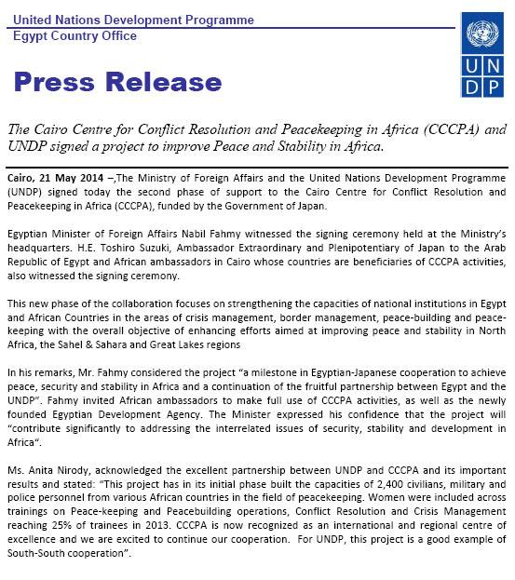

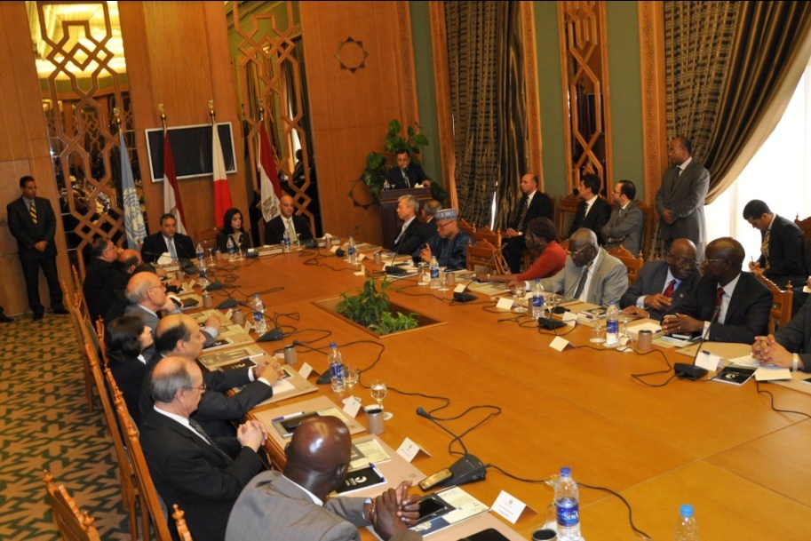

H.E. Minister Nabil Fahmy addresses the African delegates at the CCCPA Signing Ceremony (21 May, 2014)

**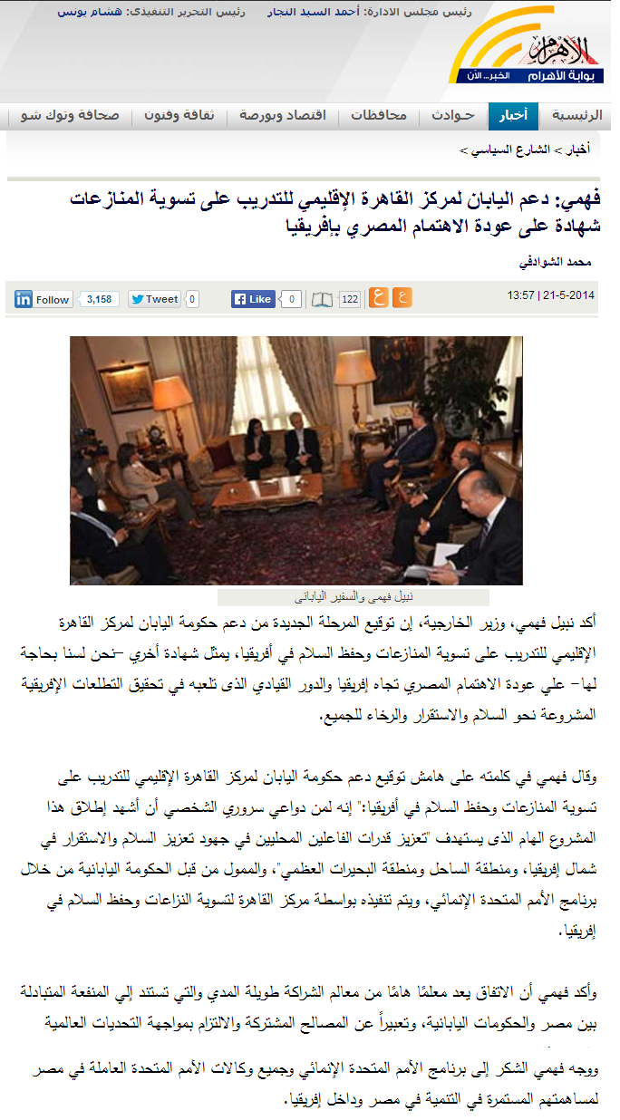**

1. Due to the delay in project document signature and the resulting delay in disbursement of funds from UNDP, the expenditures included in this report were mostly handled by CCCPA on a temporary basis and will be refunded to the Center and consequently will be reflected on UNDP’s system shortly [↑](#footnote-ref-1)